**Day5**

**MarketPlace Hackathon**

**CREATED CHECKOUT PAGE AND MADE IT FUNCTIONAL**

**1. Cart Page – Items Added**

When the customer adds items to their cart, the cart page will display a summary of the items they've selected. Each item will show:

* Product name
* Quantity selected
* Total price for that product
* Option to remove or edit the quantity of each item

**Action:**  
Once the customer has reviewed their cart, they will be prompted with a button or link to "Proceed to Checkout" . This button indicates they are ready to finalize their purchase.

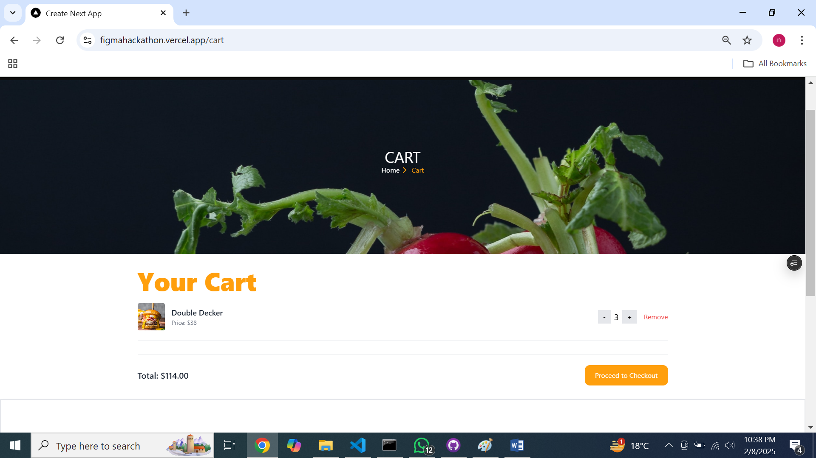

**2. Proceed to Checkout – Confirmation Popup**

After clicking "Proceed to Checkout," a confirmation popup might appear, ensuring the customer is ready to move to the next step.

* A brief reminder of their cart contents (i.e., "Are you ready to checkout?")
* A final chance to review/edit items in the cart
* Buttons for confirming (proceed to checkout) or canceling the action
* 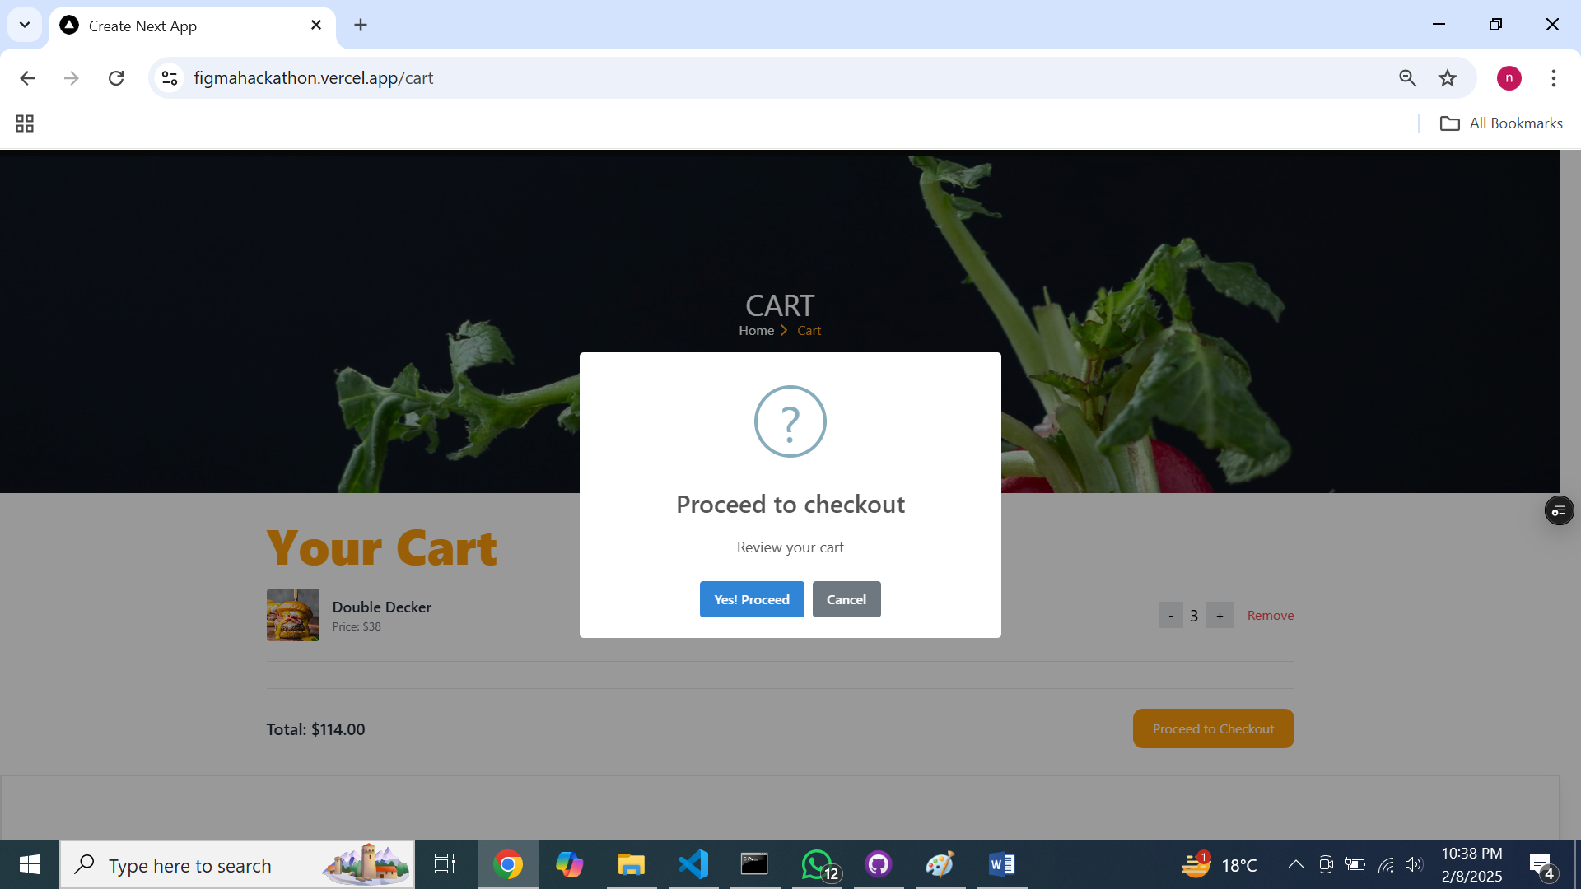

**3. Redirect to Checkout Page – Successful Transition**

Upon confirming to proceed, the customer will be directed to the **Checkout Page**. The page will load with the following sections:

**4. Order Summary Section**

At the top of the checkout page, the **Order Summary** will be displayed, giving the customer an overview of their items and totals:

* A list of the products in the cart
* Quantity of each product
* Price of each product
* Subtotal (before taxes, discounts, and shipping)

**Action:**  
This is the last opportunity for the customer to make any changes to their order before proceeding.

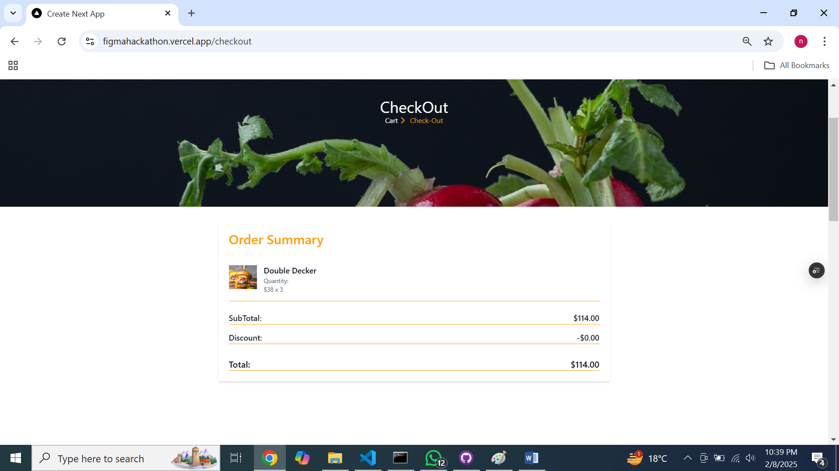

**5. Billing Information Section**

In this section, the customer is prompted to enter the required billing details:

* Full name
* Shipping address (could also include an option to ship to a different address)
* Contact information (email and/or phone number)
* Payment method (credit/debit card, PayPal, etc.)
* Billing address (if different from the shipping address)

**Action:**  
The form should validate inputs (e.g., making sure the email is formatted correctly, credit card number is valid, etc.). It may also offer an option to save the billing information for future purchases.

